Experiment No. 1 (Verification of Snell’s Second Law and Determination of Refractive Indices)
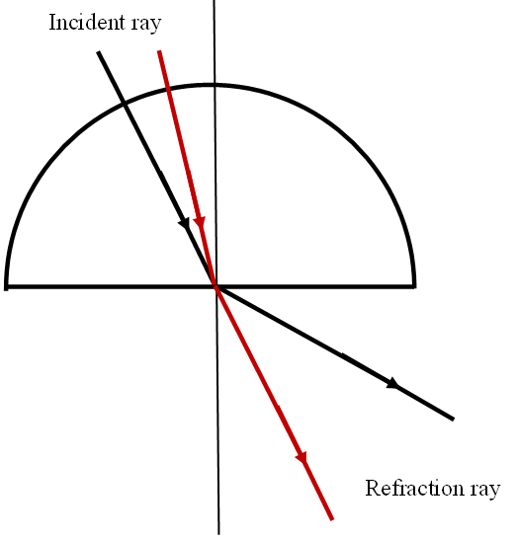
Using a sheet of paper, a rubber mat, a protractor, a compass, a semicylindrical block (or a tank half-filled with a transparent solution), and three pins, you are asked to verify Snell’s second law and to determine the refractive index of the given transparent medium.

Fig. 1
Semicylindrical block

Procedure
- Place a blank sheet of white paper on the rubber mat.
- In the middle of the sheet, draw a straight line (D). Then, using the compass, draw a circle centered on (D) with a radius of about 4.5 cm.
- Draw a perpendicular line to (D) passing through the center O of the circle.
- Insert a pin at point O, then place the semicylindrical block (or the tank) so that its flat side is parallel to (D) and the center of its curved side coincides with O (see Fig. 1).
- On the first quarter of the circle, in the clockwise direction, mark six points: P₁, P₂, P₃, P₄, P₅, and P₆.
- Using the other two pins, trace the refracted rays emerging from point O and originating from the points P₁, P₂, P₃, P₄, P₅, and P₆.
- On the same first quarter of the circle, mark the point P₀ farthest from P₁ for which a refracted ray passing through O can still be traced.
- Remove the semicylindrical block (or the tank) and the three pins from the paper sheet, then draw the incident light rays coming from P₁, P₂, P₃, P₄, P₅, P₆, and P₀ that reach point O.
- Using the protractor, measure the angles of incidence i and refraction r for each of the previous rays, then determine the value of the critical angle of refraction r₀, and fill in the following data table:
 | P1 | P2 | P3 | P4 | P5 | P6
Incidence angle i(⁰)
Refraction Angle r(⁰)
Sin i
Sin r

Data Analysis and Results
- On a sheet of graph paper, plot the graphs sin(i) as a function of sin(r). Comment on the graphs obtained.
- Based on the graphs from question 1, can a simple mathematical law be established that expresses the angle of incidence i as a function of the angle of refraction r of a light ray? If yes, which one?
- Is Snell-Descartes’ law of refraction verified in this case? If not, in your opinion, what are the main sources of error?
- Can we determine, from the graph, the average refractive index n of the glass in the semicylindrical block (or of the solution in the tank)? If yes, how? Then specify the value of n. The average refractive index of air is assumed to be 1.
- Can the same refractive index n also be determined from the critical angle r₀? If yes, how? Then specify the value of n, and compare it to the one obtained in question 4.
- Conclusion.

Experiment No. 2 (Property of a Prism for Monochromatic Light (*) and Determination of the Average Refractive Index of Transparent Materials — Solid and Liquid)
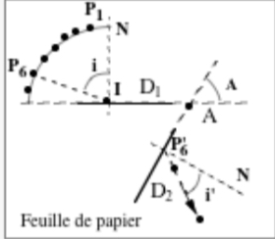
Using a rubber mat, a glass block (or a tank filled with a transparent liquid), a protractor, and four pins, you are asked to trace the path of a light ray passing through a prism, determine its total deviation (Δt) as a function of the angle of incidence (i), and then deduce the average absolute refractive index of the glass (or of the liquid in the tank).
Fig. 2

Procedure
- Place a sheet of white paper on the rubber mat.
- In the middle of the sheet, place the glass block (or the tank), and using a pencil and the sides of the block, draw two straight segments D₁ and D₂ (see Fig. 2).
- Remove the glass block (or the tank) from the paper sheet, then determine the apex A of the prism by extending the straight segments D₁ and D₂.
- On one of the traces of the faces of the block (or the tank) forming the angle A, mark a point I, then draw the normal N passing through I and perpendicular to D₁ (or D₂).
- At point I, draw a quarter of a circle centered at I, with a radius equal to that of your protractor. This arc should intersect the normal N and the line segment D₁ (or D₂).
- On this quarter circle (see Fig. 2), mark, starting from the normal N, seven points P₁, P₂, P₃, P₄, P₅, P₆, and P₇, such that the angles (NI, IPᵢ), for i = 1 to 7, are respectively 16°, 26°, 36°, 46°, 56°, 66°, and 76°.
- Draw the seven incident rays entering the prism at I (PᵢI, for i = 1 to 7).
- Place the glass block (or the tank half-filled with the transparent liquid) so that its faces coincide with D₁ and D₂.
- Using two pins, trace the incident ray coming from P₁ and striking the prism at I. Then, using the other two pins and the sighting method, trace the corresponding emergent ray. Repeat this procedure for the six other points.
- With a protractor, measure the apex angle A of the prism, and the angles of incidence i and emergence i′ for the seven light rays. Record the measured results in the table below.
Points | P1 | P2 | P3 | P4 | P5 | P6 | P7
i (⁰)
i' (⁰)
i +i'-A (⁰)

Data Analysis and Results
- Plot the graph of (i + i′ – A) as a function of i.
- Comment on the previous graph.
- Can the average refractive index of the glass block (or of the liquid contained in the tank) be determined for white light?
If yes, what is its estimated value? Explain.

